Jonathan Quang 2/23/2015

Prelab #2 Features of the Frog SLS44-09/Period 4,5

Prelab #2 External Features and Leg Musculoskeleton of the Frog

1. The structure all vertebrates share is a backbone.

2. The term amphibian means double life. This is a proper classification of frogs because when they hatch from their eggs, they start life out as tadpoles. These tadpoles are herbivores that have tails and gills. As they mature, they turn into adults as frogs that have four legs, practically no tail, and may become carnivores.

3. It is difficult to tell whether a frog is male or female just from appearance. The cloaca is a small opening at the end of the frog. Wastes are eliminated from here as well as functioning as the exit point for eggs in females and sperm in males. Since all frogs have cloaca regardless of gender, it would be hard to tell whether the frog is a female or male just from external anatomy.

4. The important function the skin of a frog performs is respiration. When moist, the skin functions as a surface for gas exchange.

5. The eyes of a frog are angled to the sides whereas the eyes of a humans face forward. This is advantageous to the frog because it allows the frog to see what is in front of it as well as what is at its sides.

6. The function of the tympanic membrane is to transfer sound waves from the air into the frog's inner ear. The membrane is similar to the human eardrum, which takes sound waves that travel into the ear canal and transfers it to the ossicles inside the middle ear. The ossicles then amplify the sound wave and pass it off to the inner tear.

7.Forelimbs are smaller and less muscular in comparison to hind legs because the hind legs are used to swim and jump. The need to use the hind legs to jump means that it must be more muscular to complete the action.

8. Muscles found in the upper leg of a frog are responsible for moving the frog's lower leg or calf.

9. Muscles found in the lower leg are responsible for moving the frog's foot.

10. The anterior side is at box D. The dorsal side is at box B. The posterior side is at box A. The ventral side is at box E. The torso is at point C.

E

A

B

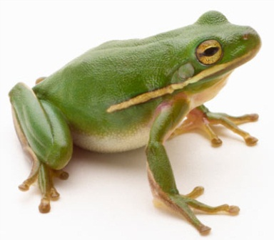

D

C

Bibliography

A & P Course Objectives. (n.d.). Retrieved February 24, 2015, from http://www.fastol.com/~renkwitz/a_&_p_course_objectives.htm

Human Body Anatomy. (n.d.). Retrieved February 24, 2015, from http://humananatomypics.com/tag/diagram-of-the-upper-respiratory-systems

Virtual Frog Dissection. (n.d.). Retrieved February 24, 2015, from http://www.mhhe.com/biosci/genbio/virtual_labs/BL_16/BL_16.html